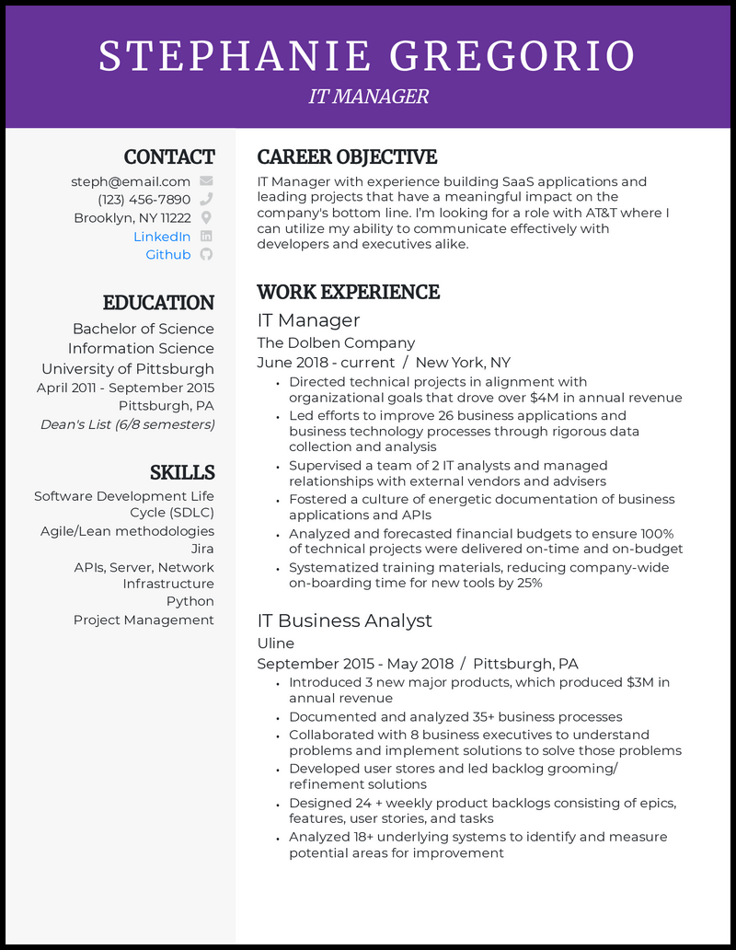
STEPHANIE GREGORIO
CONTACT
steph@email.com
(123) 456-7890 Brooklyn, NY 11222
LinkedIn in Github
EDUCATION Bachelor of Science Information Science University of Pittsburgh April 2011 - September 2015 Pittsburgh, PA
Dean's List (6/8 semesters)
SKILLS
Software Development Life Cycle (SDLC)
Agile/Lean methodologies
Jira
APIs, Server, Network
Infrastructure
Python
Project Management
IT MANAGER
CAREER OBJECTIVE
IT Manager with experience building SaaS applications and leading projects that have a meaningful impact on the company's bottom line. I'm looking for a role with AT&T where I can utilize my ability to communicate effectively with developers and executives alike.
WORK EXPERIENCE
IT Manager
The Dolben Company
June 2018 - current / New York, NY
⚫ Directed technical projects in alignment with
.
organizational goals that drove over $4M in annual revenue
• Led efforts to improve 26 business applications and business technology processes through rigorous data collection and analysis
.
• Supervised a team of 2 IT analysts and managed relationships with external vendors and advisers
⚫ Fostered a culture of energetic documentation of business applications and APIs
• Analyzed and forecasted financial budgets to ensure 100% of technical projects were delivered on-time and on-budget . Systematized training materials, reducing company-wide on-boarding time for new tools by 25%
IT Business Analyst
Uline
September 2015 - May 2018 / Pittsburgh, PA
. Introduced 3 new major products, which produced $3M in annual revenue
⚫ Documented and analyzed 35+ business processes
.
Collaborated with 8 business executives to understand
problems and implement solutions to solve those problems • Developed user stores and led backlog grooming/ refinement solutions
. Designed 24 + weekly product backlogs consisting of epics, features, user stories, and tasks
.
• Analyzed 18+ underlying systems to identify and measure potential areas for improvement

